Chapter 6: Stacks

Concepts
Stacks and Queues can be implemented with a linked list or with an array. The important thing about these structures is how they manage the data within them – they restrict access to data except for what’s on top (for Stacks), or what is in front (for Queues).
Stacks and Queues are relatively simple data structures, functionality-wise. Their functions include:
Stack | Last-in-first-out | Queue | First-in-first-out
size | get the size of the stack | size | get the size of the queue
top | get the top-most item | front | get the front-most item
push | add a new item to the top | push | add a new item to the back
pop | remove the item on top | pop | remove the item in front

Think of a Stack like a Pringles can, where you can only access the top-most chip (crisp?). If you have an empty Pringles can, the chip that’s added first is on the bottom. If you add more chips on top, you cannot access the bottom-most chip until all the chips above it are gone.
A Queue should be pretty self-explanatory; just like lining up at Micro Center, the first person in line is the first person who gets to leave. As more people enter the line, they line up at the end – or the back – of the queue.

Stack functionality

Push
As items are added to the stack, you begin filling it from bottom-to-top.
First, Push “A” | Second, Push “B” | Third, Push “C”
A |  | C  B  A  B  A

Pop
Pop removes the top-most item.
Stack with items in it | Pop removes “C” | Pop removes “B”
C  B  A  B  A |  | A

Top
Top returns the data in the top-most item.
x
Top returns 1 | Top returns “C” | Top returns “x”
1  5  8 | C  B  A

Uses of a Stack

Function calls
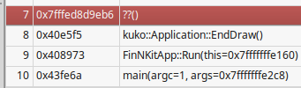
A stack can be used in various ways in computer science. Remember the Call Stack debugging tool? It will show you the list of functions called up until your current point.
Whenever a function is called, it is pushed onto the stack. To return from the function and go to the last function, you Pop the current function off the stack to easily return to the previous function.

Screen states
Different screens in a program are sometimes designed to be pushed and popped on stacks. For example, let’s say you’re using your GPS.
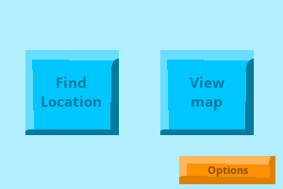  MainMenu | When it boots up, it starts at the main menu. This gets pushed on the stack.
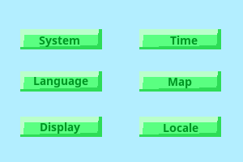  MainMenu  Options | You click on “Options”. The Options menu gets pushed onto the stack next.

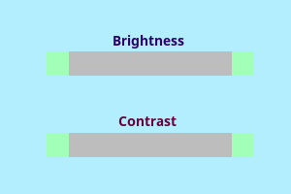  MainMenu  Options  Display | You click on “Display”, and the Display menu gets pushed onto the stack.  Once you’ve adjusted the display, you hit the Back button. This pops Display off the top.
MainMenu  Options | Since Display was popped, the top-most menu is now Options again.  You hit Back again, and it pops Options off the top.
MainMenu | Options was removed, so the next menu is the main menu.

Syntax checking – verifying braces

String recognition

Postfix expressions

(Work in progress)

